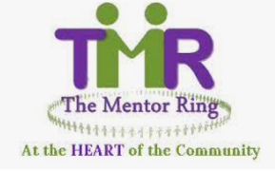

Bid Writer
About us:

The Mentor Ring was established in 2010 and is a socially inclusive organisation built on the principles of respect for human rights, diversity with our society and the promotion of equality for all. We run a series of peer mentoring sessions across South Wales, providing education, employment, health, and community cohesion primarily to BAME communities.

Our vision is that no individual should be excluded from active participation in employment, training, education, community life or leisure and social activities because of cultural, language, physical, mental, or emotional health and well-being issues or lifestyle choices; and that everyone should be able to enjoy a healthy self-esteem and reach their full potential.

About the role:

We have an excellent opportunity to fill a new role within The Mentor Ring as a bid writer/fundraiser. In this role you will research, design, write and submit detailed applications for capital and revenue funds to support our services. This will be an exceptional opportunity for a driven individual to build new networks and to establish, develop and maintain new fundraising initiatives for the charity.
An important aspect of this role will be to build relationships across a wider network within Cardiff, Newport and Swansea, supporting and educating the organisation on best practices, such as storyboarding and staged reviews and driving the development of our bid value proposition.
We are proud to be members of the Defence Employer Recognition Scheme and encourage applications from service leavers and those associated with the service community.
Hours: 21 hours/week – Based in Cardiff and occasional travel to Newport, Swansea
Salary – £ 12541
Employment terms: 12-month fixed term contract from start of employment
If you are interested, please email : info@MentorRing.org.uk

Closing date: 30th June 2022
Interviews will be held in Cardiff
‘This post is funded by the Third Sector Resilience Fund for Wales Phase 2 Scheme, managed and administered by WCVA on behalf of Welsh Government’

