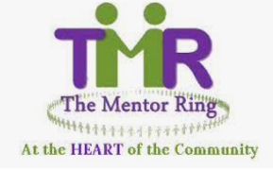

Project Co-ordinator

About us:

The Mentor Ring was established in 2010 and is a socially inclusive organisation built on the principles of respect for human rights, diversity with our society and the promotion of equality for all. We run a series of peer mentoring sessions across South Wales, providing education, employment, health, and community cohesion primarily to BAME communities.

Our vision is that no individual should be excluded from active participation in employment, training, education, community life or leisure and social activities because of cultural, language, physical, mental, or emotional health and well-being issues or lifestyle choices; and that everyone should be able to enjoy a healthy self-esteem and reach their full potential.

About the role
We have an excellent opportunity to fill a new role within The Mentor Ring as a Project Co-ordinator. In this role you will oversee all TMR projects and the responsibility to expand them. The role requires a thorough understanding of current issues relating to BAME communities and a proven ability to build and maintain strong strategic relationships with colleagues and external organisations in Newport and Swansea. The successful candidate will be able to recognise, understand and respond to the needs of different stakeholders. They will also have excellent communication, project management and planning skills.
We are proud to be members of the Defence Employer Recognition Scheme and encourage applications from service leavers and those associated with the service community.
Hours: 35 hours/week –Mostly in Newport. Involve weekly staff meetings at Cardiff Offices
Salary - £ 23,000
Employment terms: 12-month fixed term contract from start of employment
If you are interested, please email: info@mentorring.org.uk

Closing date: 30th June 2022
Interviews will be held in Cardiff
‘This post is funded by the Third Sector Resilience Fund for Wales Phase 2 Scheme, managed and administered by WCVA on behalf of Welsh Government’

