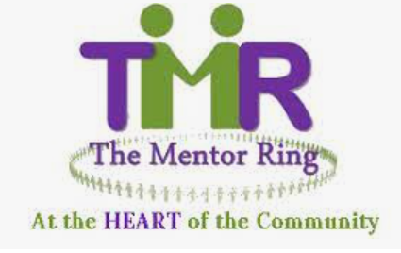

Bid Writer

Job Description

Post: | Bid Writer
Reports to: | Chief Executive
Hours of Work: | 21 hours working from TMR offices based in Butetown, Cardiff CF10 5JA
Salary: | £12541

Context
The Mentor Ring’s vision is that no individual should be excluded from active participation in employment, training, education, community life or leisure and social activities because of cultural, language, physical, mental, or emotional health and well-being issues or lifestyle choices; and that everyone should be able to enjoy a healthy self-esteem and reach their full potential. We run a series of peer mentoring sessions across South Wales, providing education, employment, health, and community cohesion primarily to BAME communities.

Job Summary
We have an opportunity to fill a new role within The Mentor Ring - a bid writer/fundraiser to research, design, write and submit detailed applications for capital and revenue funds to support our services. This will be an exceptional opportunity for a driven individual to build new networks and to establish, develop and maintain new fundraising initiatives for the charity.
An important aspect of this role will be to build relationships across a wider network, supporting and educating the organisation on best practices, such as storyboarding and staged reviews and driving the development of our bid value proposition.

Responsibilities

Personal Specification

Skill & Knowledge

Essential

- Good understanding and knowledge of trusts, statutory and lottery fundraising and the voluntary sector.
- IT literate (ideally with experience of Microsoft Office) with strong administrative and numeracy skills.
- Excellent verbal and written English presentation and communication skills, including the ability to write funding briefs, reports, proposals and correspondence.
- Strong analytical, interpretative, evaluative, and organisational skills.
- Knowledge and understanding of an outcome-based approach to measuring and monitoring performance.
- Experience of monitoring and evaluation
- A high level of motivation, ability to work with minimum supervision but still capable of working as an effective team member
- Ability to meet specific deadlines under pressure
- Ability to deliver workshops and presentations

Desirable

- Experience of working in the charity sector
- Ability to manage staff

Qualifications & Training

- A good standard of education and experience

Disposition

- Enthusiastic, highly motivated.
- Able to maintain confidentiality.
- Committed to equality of opportunity.
- Willing to undertake training and development relevant to the post.

